## Importing ML in .net with model builder

## Download and install

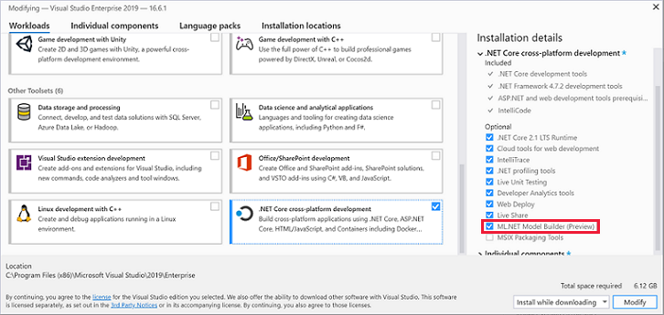

Enable Preview Feature

**Tools** > **Options** > **Environment** > **Preview Features**

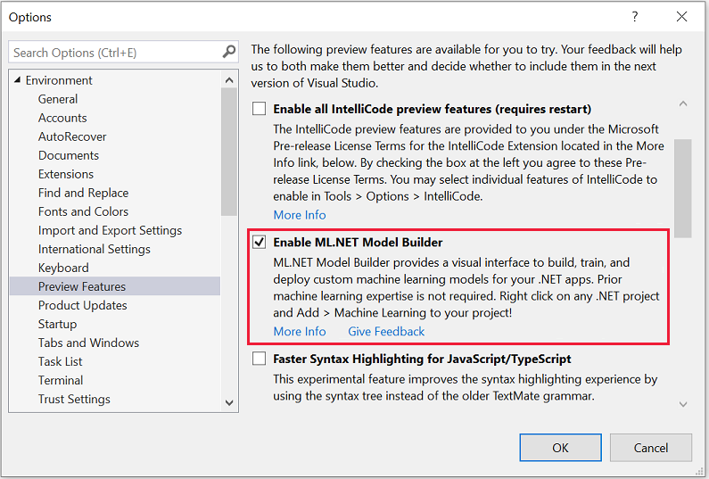

## Create your app

Open Visual Studio and create a new .NET Core console app:

1. Select **Create a new project** from the Visual Studio 2019 start window.
2. Choose the **C# Console App (.NET Core)** project template.
3. Change the project name to myMLApp.
4. Make sure **Place solution and project in the same directory** is unchecked.
5. **Create** the project.

### Add machine learning

### Pick a scenarioModel Builder supports classification, value prediction, recommendation, and image classification scenarios.

## Download and add data

### Add data

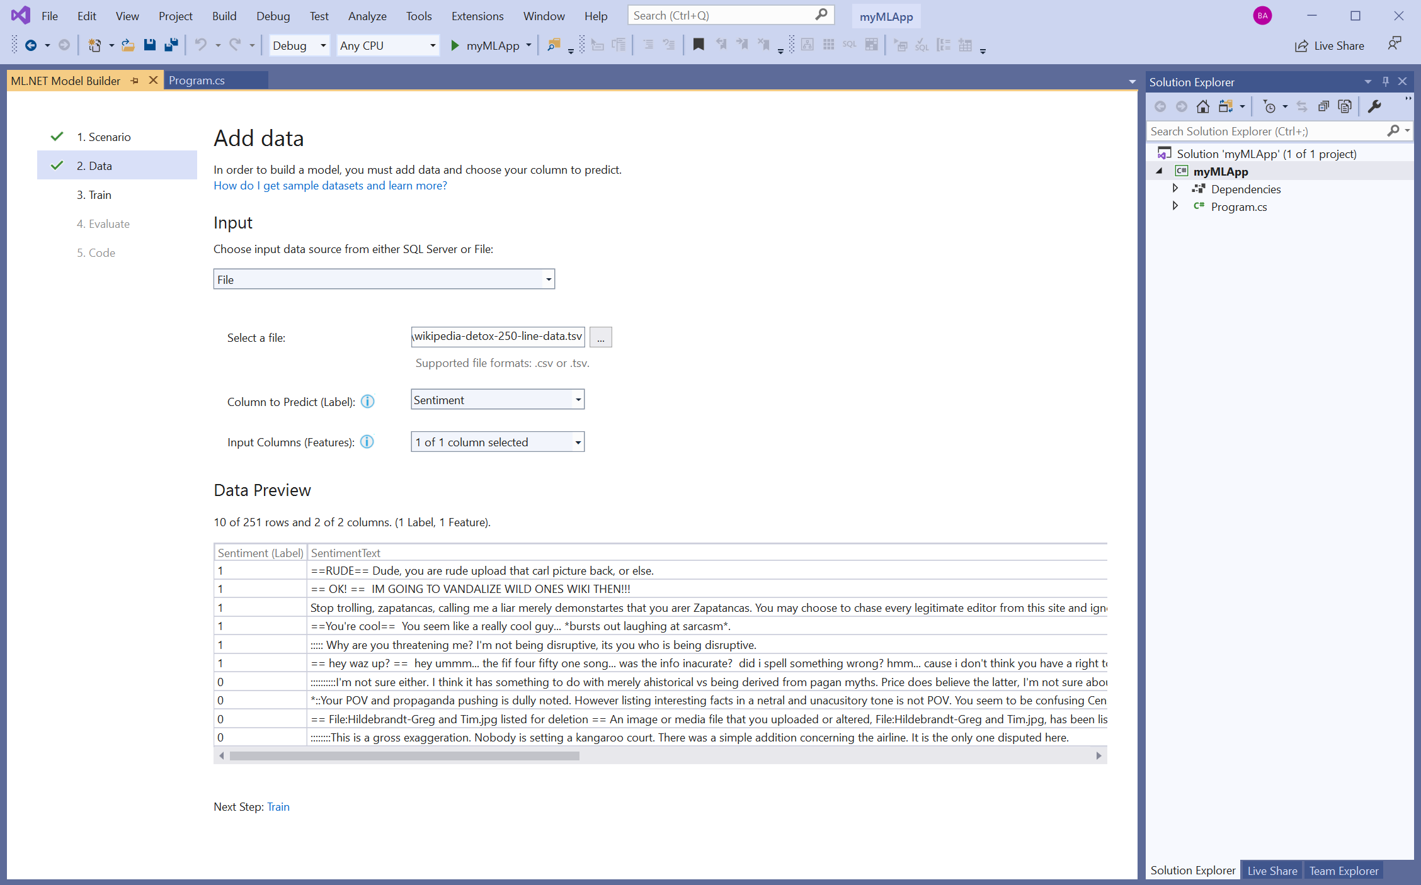

## Train your model

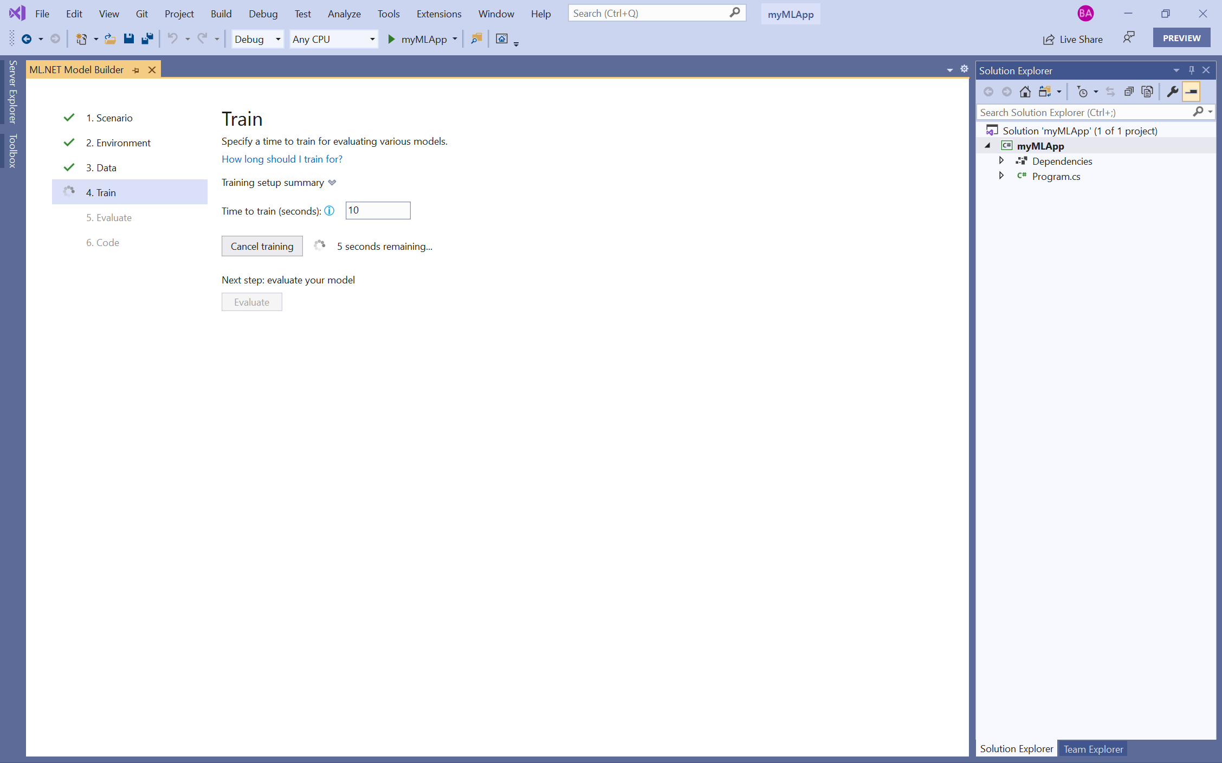

### Training results

### https://dotnet.microsoft.com/static/images/model-builder-done-training.png?v=7VA6iaIgRz-Z_BwQlvhy-JvP3Ne5Sx0ClvcViJQbcWQ

## Evaluate your model

### https://dotnet.microsoft.com/static/images/model-builder-evaluate-model.png?v=L7_fh6q7zcKVzQTkNn68D_K4SFPxqmk2dI2u6pEqNjo

## Generate code

### in the **Code** step in Model Builder, select **Add Projects**.

### mlMLAppML.ConsoleApp and myMLAppML.Model projects are added to the myMLApp solution

## Consume your model

### code